Project title | Restaurant
Author(s) | Mesesan Mara
Group | 30424

Task Description

This project represents a Restaurant management.

In the beginning the user must complete the name and surname fields so they can make an account or log into an already existent one so they can make orders and reservations.

After this, a frame containing the Home page opens, there the user can chose to make a reservation at a table in the restaurant or to just make an order if they already have a reservation made. The only requirement so that you can make an order in the restaurant is to have a reservation. An error will appear if the customer doesn’t have a reservation made

For making a reservation at the Restaurant the client is asked a few questions: the number of people present, the date in which they want to come (those 2 actions will generate tables that will show the disponibility) and after that to chose a table. When pressing the “Make reservation” button, the reservation is read.
After this they have to return to the main page to make an order.

The order page is divided by the type of food a person might want: breakfast, starter, main course and dessert. Each of these have a few selections of food that the customer can chose from, and chose the quantity.

After this the Cart page shows the purceses the person has done and from there they can place the order and see the cost of the bill.

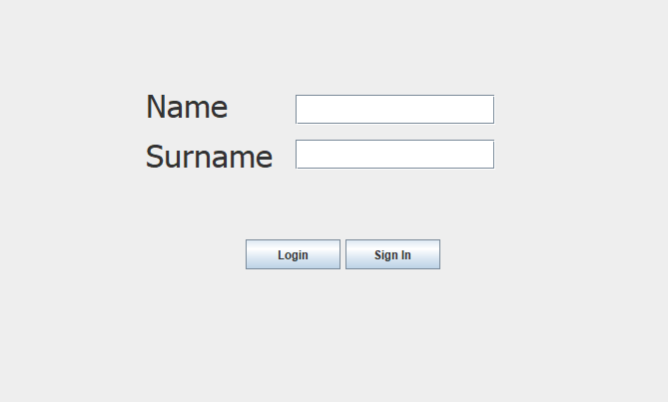

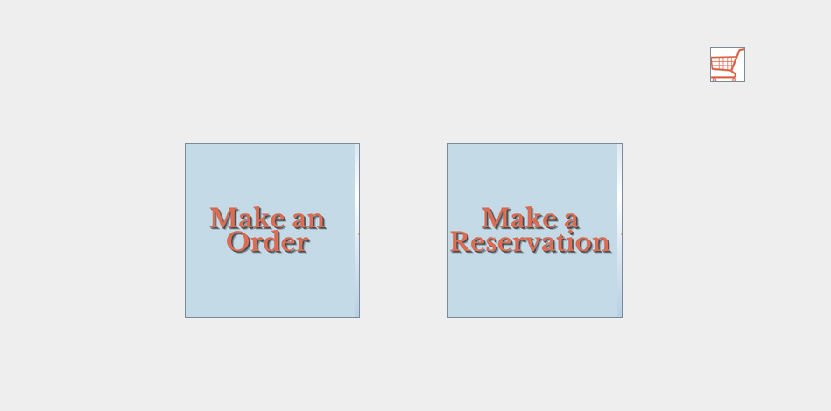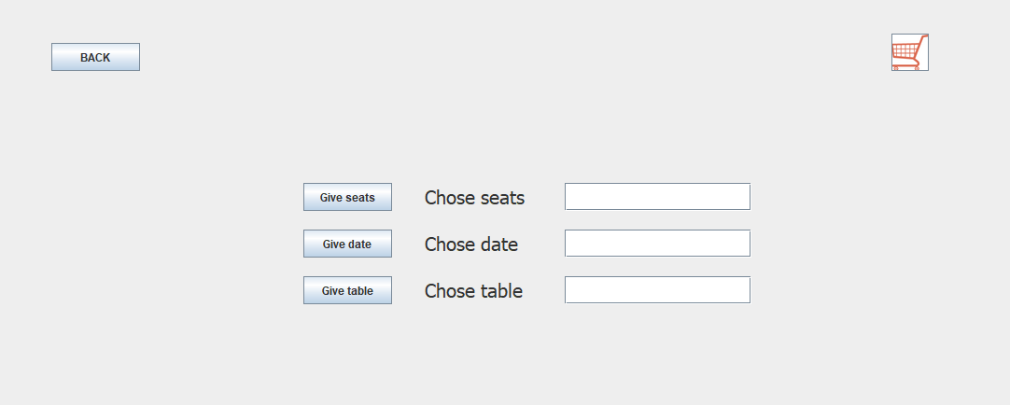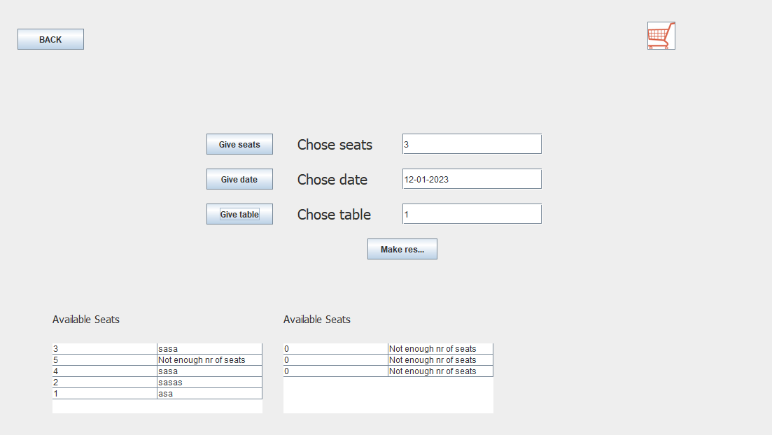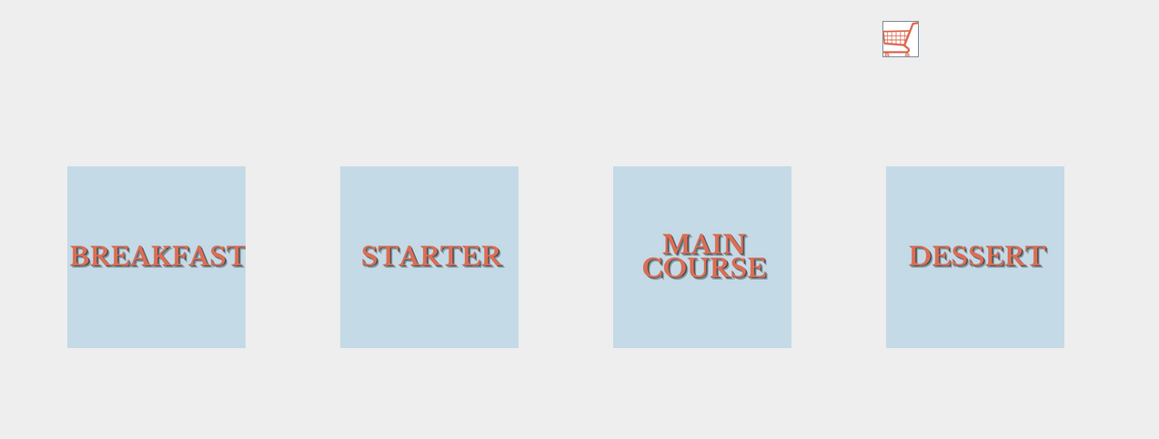

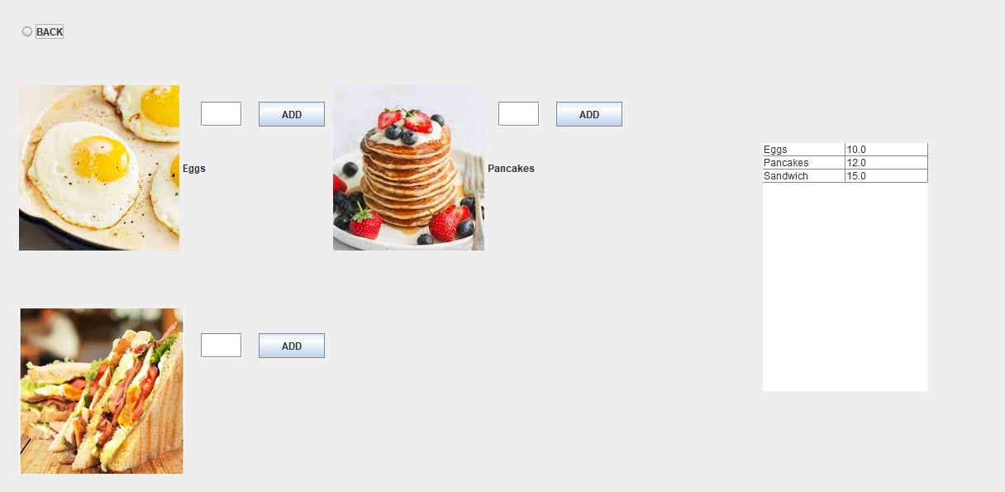

Class Diagram
Class diagrams for your application as found using the CRCs above. If the class diagram grows big and does not fit, put the big picture first without details and then the diagrams for each class as in the example below.

Bill
Id_bill:int
Id_order:int
Price:float
+getters
constructor
Bookings
private int id_booking;
private int id_customer;
private int table_nr;
private int nr_persons;
private String date;

Getters, constructor

DBConnection
String url;
String user;
String password;
public RowTableSeats[] rts = new RowTableSeats[20];
public RowTableSeats[] rts2 = new RowTableSeats[20];
public RowTableMenue[] rtm = new RowTableMenue[200];
public RowTableOrder[] rto = new RowTableOrder[20];

Getters, constructor
addCustomer (Customer c)
deleteCustomer(int id)
selectCustomer
selectCustomerByName(String name)
selectCustomerById(int id)
makeReservation(Booking b)
boolean customerExists(int id)
boolean alreadyRegistered(String c_name, String c_surname)
selectBookingBySeats(int nr_seats)
void selectBookingByDate(String date)
void selectBookingByDate2(String date)
int selectBookingByName(String name, String date, String surname)
void choseFoodByMeal(String meal)
int increseId(int max_id)
int increseIdBooking(int max_id)
int id_order_by_booking(int booking)
int idFoodByName(String name)
void insertInOrder(MenueItemOnOrder o)
int calculateBill(int id_order)
void insertBill(Bill b)
int increseIdMIOO(
int increseIdOrder(
int increseIdBill()
void createOrder(int order_id, int booking_id)
void selectFoodByOrder(int id_order)

